INSTAGRAM DATABASE CLONE

Users
Photos
Comments
Likes
Hashtags
followers/Followees

- Users Schema

Code:

- CREATE TABLE users (
- id INTEGER AUTO_INCREMENT PRIMARY KEY,
- username VARCHAR(255) UNIQUE NOT NULL,
- created_at TIMESTAMP DEFAULT NOW()
- );

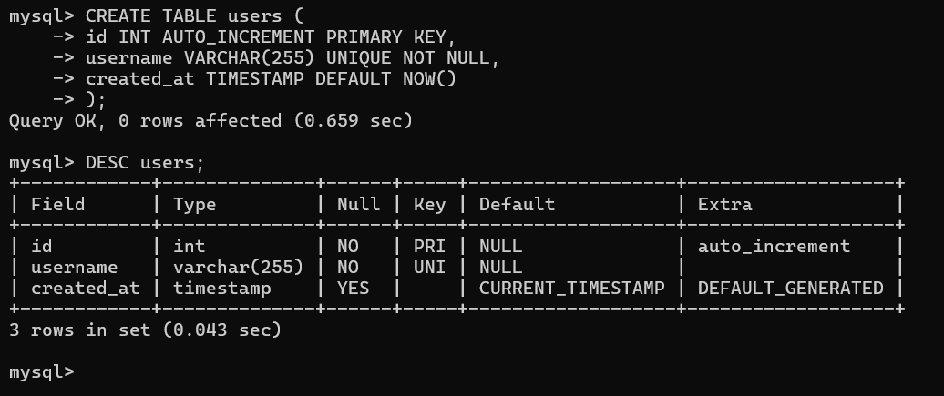

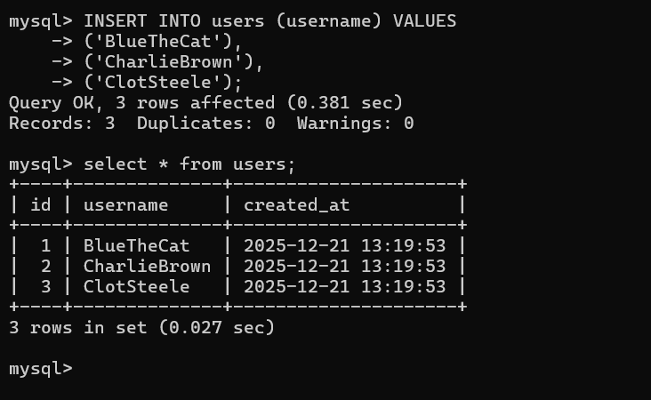

- Photos Shema

- CREATE TABLE photos (
- id INTEGER AUTO_INCREMENT PRIMARY KEY,
- image_url VARCHAR(255) NOT NULL,
- user_id INTEGER NOT NULL,
- created_at TIMESTAMP DEFAULT NOW(),
- FOREIGN KEY(user_id) REFERENCES users(id)
- );

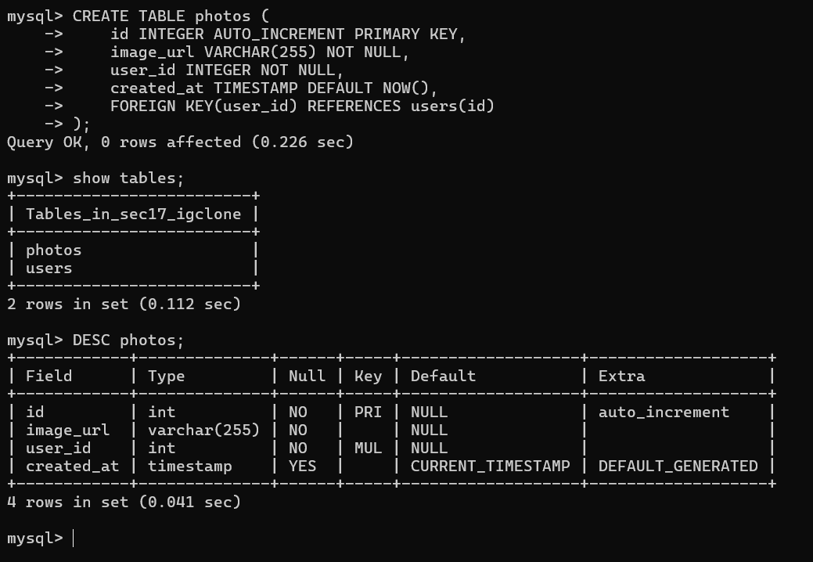

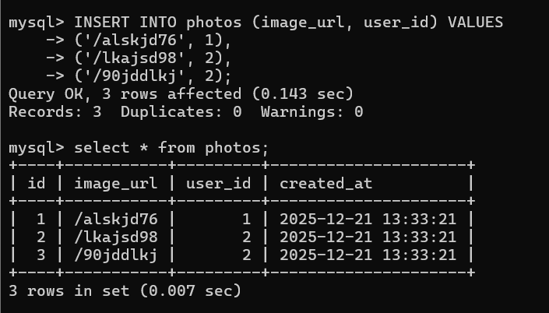

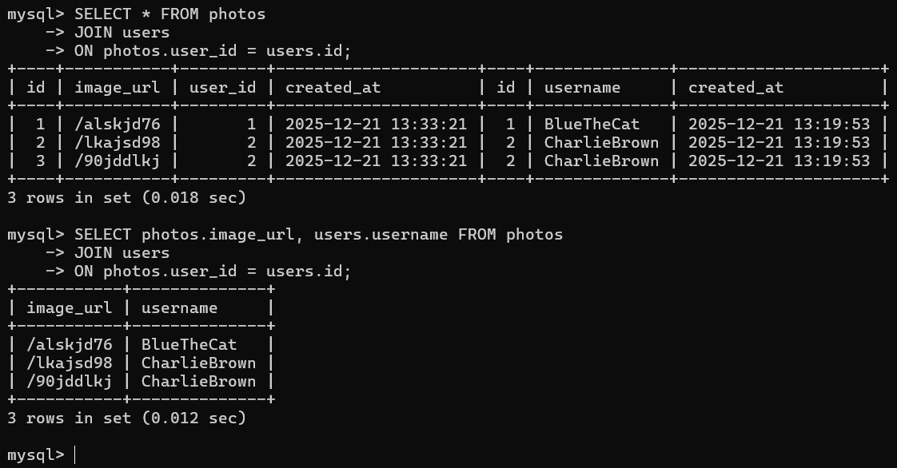

- COMMENTS SCHEMA

CODE:

- CREATE TABLE comments (
- id INTEGER AUTO_INCREMENT PRIMARY KEY,
- comment_text VARCHAR(255) NOT NULL,
- photo_id INTEGER NOT NULL,
- user_id INTEGER NOT NULL,
- created_at TIMESTAMP DEFAULT NOW(),
- FOREIGN KEY(photo_id) REFERENCES photos(id),
- FOREIGN KEY(user_id) REFERENCES users(id)
- );

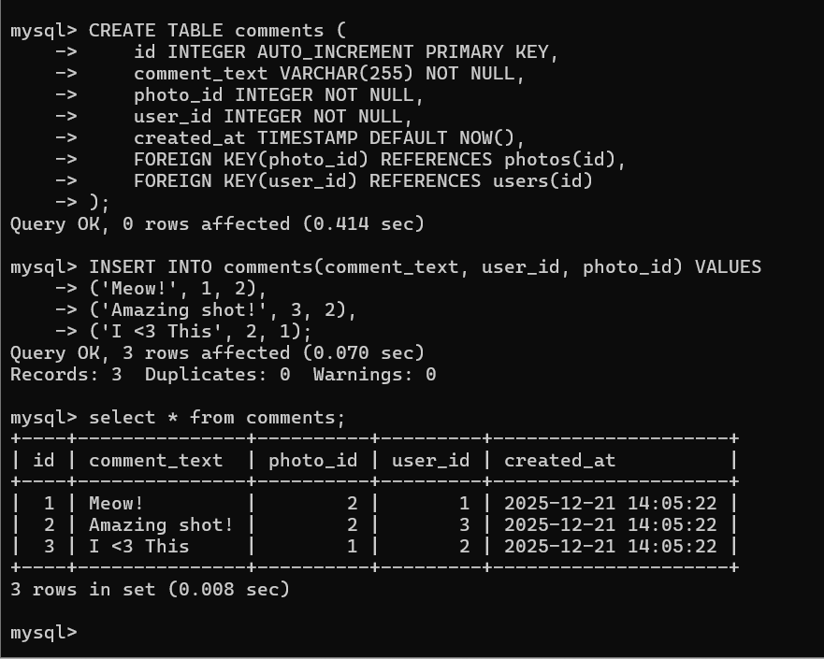

- LIKES SCHEMA

CODE:

- CREATE TABLE likes (
- user_id INTEGER NOT NULL,
- photo_id INTEGER NOT NULL,
- created_at TIMESTAMP DEFAULT NOW(),
- FOREIGN KEY(user_id) REFERENCES users(id),
- FOREIGN KEY(photo_id) REFERENCES photos(id),
- PRIMARY KEY(user_id, photo_id)
- );

I like photo with ID of three.

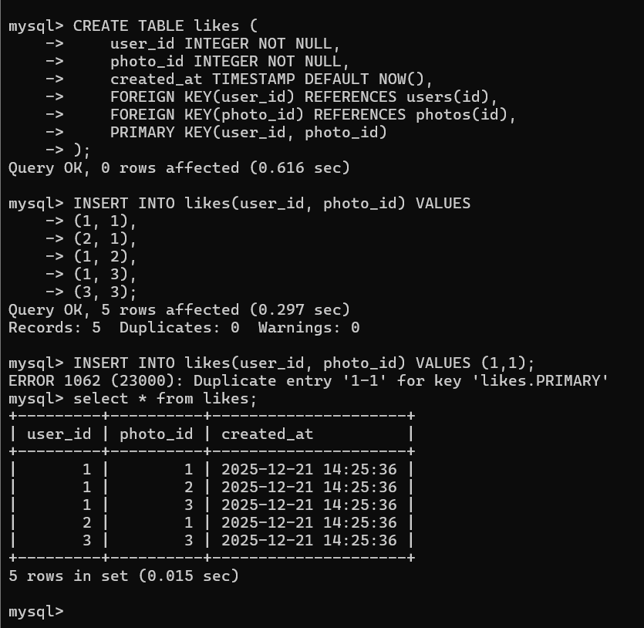

(1, 3)
user_id = 1 → the user with ID 1
photo_id = 3 → the photo with ID 3

means
User 1 liked Photo 3
- FOLLOWERS SCHEMA

CODE:

- CREATE TABLE follows (
- follower_id INTEGER NOT NULL,
- followee_id INTEGER NOT NULL,
- created_at TIMESTAMP DEFAULT NOW(),
- FOREIGN KEY(follower_id) REFERENCES users(id),
- FOREIGN KEY(followee_id) REFERENCES users(id),
- PRIMARY KEY(follower_id, followee_id)
- );

Users table:
____________________________________________________

Id Username created_at

1 Tommy 2016-10-11
2 Bluecat 2017-01-10
3 coltsteele 2017-04-04
_____________________________________________________

Follows table:
_____________________________________________________

Follower_id Followee_Id created_at
3 2 2017-03-03
3 1 2017-04-04
2 3 2017-05-05
______________________________________________________

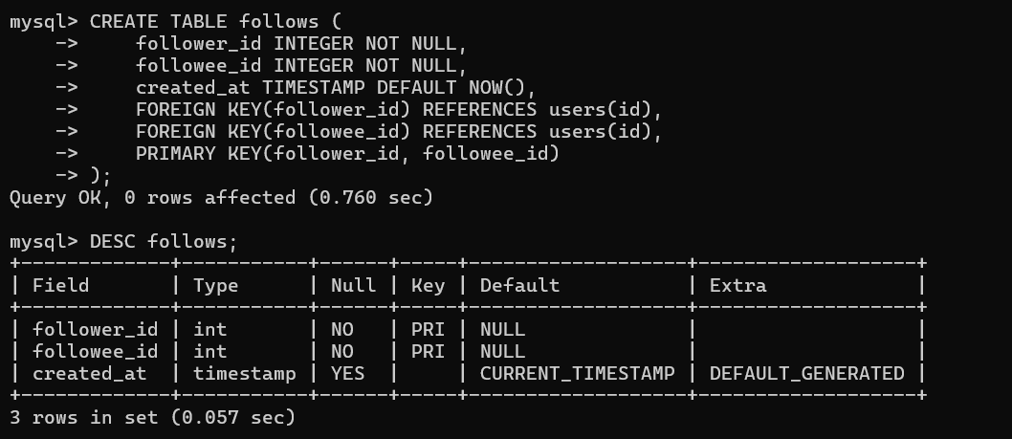

Blue follows Charlie Brown. Insert Into follows(follower_id, followee_id) VALUES (1,2) => “Blue follows Charlie Brown” (1,3) => “Blue follows Colt steele”
(3,1) => “Colt Steele follows Blue” (2,3) => “Charlie Brown follows colt steele”.

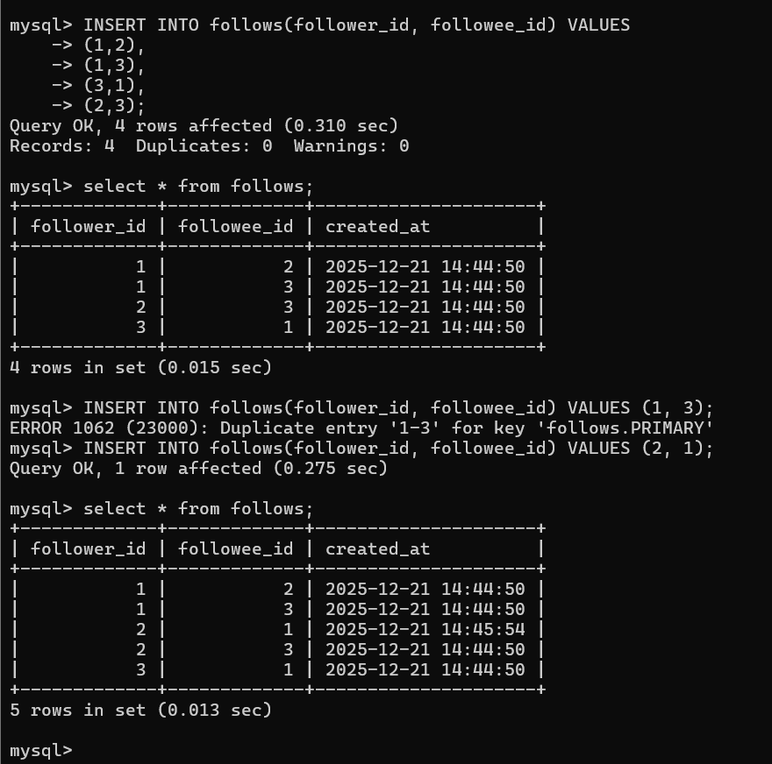

- Approaches for Hashtags

Solution1

Id image_url caption tags

1 ‘/klaserg123’ ‘My Cat’ ‘#cat#pets#animals#cute#omg’
1 ‘/klaserg123’ ‘My Cat’ ‘#cat#pets#animals#cute#omg’
1 ‘/klaserg123’ ‘My Cat’ ‘#cat#pets#animals#cute#omg’

Limited number of tags can be stored cannot store additional information have to be careful with searching.

___________________________________________________________

Solution2

1Photos 2Tags

Id image_url caption | tag_name photo_id
1 ‘/klaserg123’ ‘My cat’ | ‘#cute’ 1
2 ‘/klaserg123’ ‘My meal’ | ‘#cute’ 3
3 ‘/klaserg123’ ‘A Selfie’ | ‘#microwave’ 2
‘#ego’ 3
‘#smile’ 3
‘#gross’ 2

Unlimited Number of Tags Slower than Previous solution.

____________________________________________________________

Id image_url caption
1 ‘/klaserg123’ ‘My Cat’
1 ‘/klaserg123’ ‘My Cat’
1 ‘/klaserg123’ ‘My Cat’

2Tags

tag_name id
‘#cute’ 1
‘#pets’ 2
‘#microwave’ 3
‘#ego’ 4
‘#smile’ 5
‘#gross’ 6
____________________________________________________________
3 Photo_tags

Photo_id tag_id

1 1
1 2
2 3
2 6
3 1
3 4
3 5

Unlimited Number of Tags can add additional information.
More work when inserting/updating have to work about orphans.

Photo_id 1 is “my cat” tagged with “cute”.
Photo_id 2 is “my cat” tagged with “pets”.

____________________________________________________________

- Implementing Hashtag Table

CODE:

- CREATE TABLE tags (
- id INTEGER AUTO_INCREMENT PRIMARY KEY,
- tag_name VARCHAR(255) UNIQUE,
- created_at TIMESTAMP DEFAULT NOW()
- );
- CREATE TABLE photo_tags (
- photo_id INTEGER NOT NULL,
- tag_id INTEGER NOT NULL,
- FOREIGN KEY(photo_id) REFERENCES photos(id),
- FOREIGN KEY(tag_id) REFERENCES tags(id),
- PRIMARY KEY(photo_id, tag_id)
- );

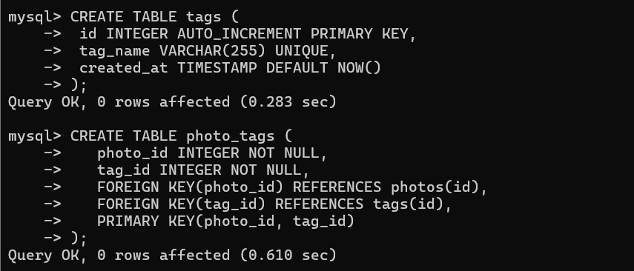

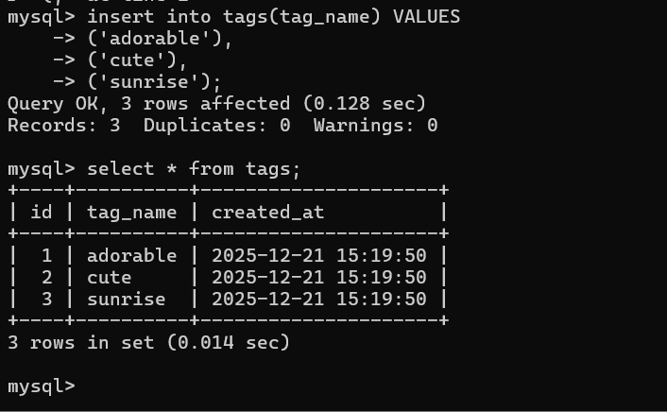

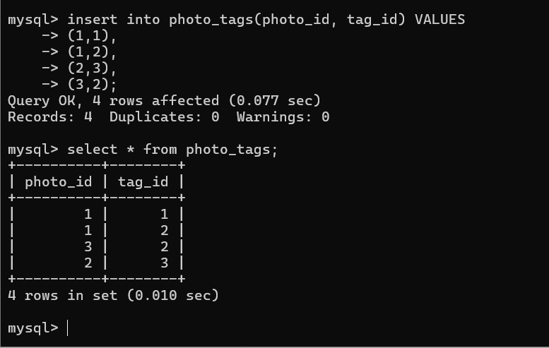

“ (1,1) first photo tagged adorable. (1,2) first photo tagged cute. (3,2) third photo tagged cute. (2,3) second photo tagged sunrise. “

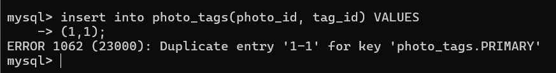
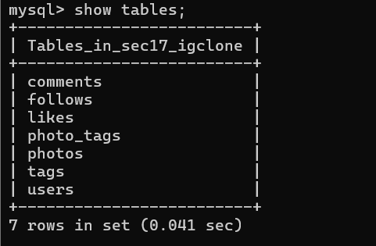

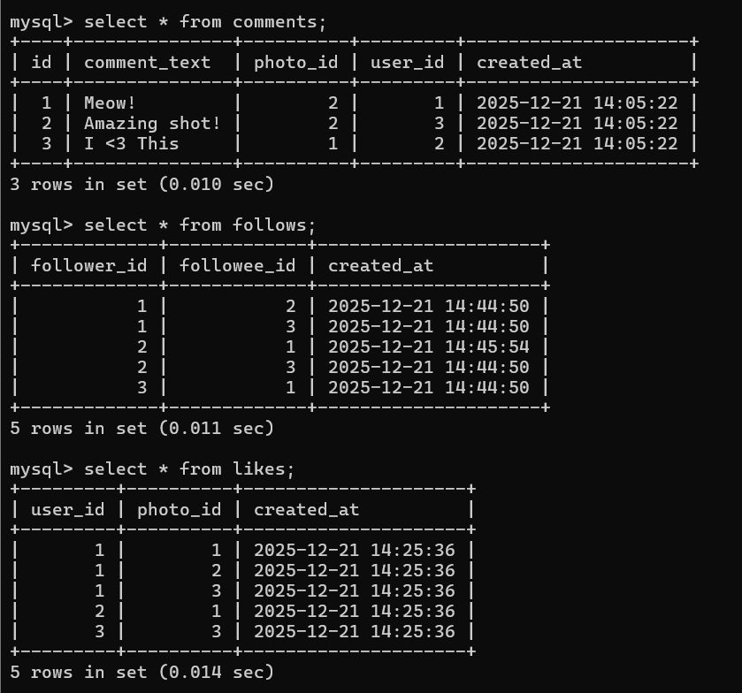

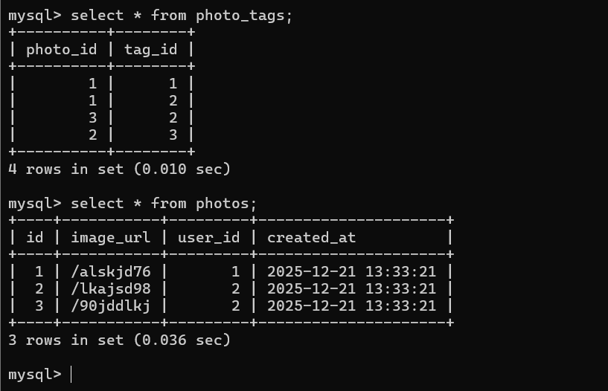

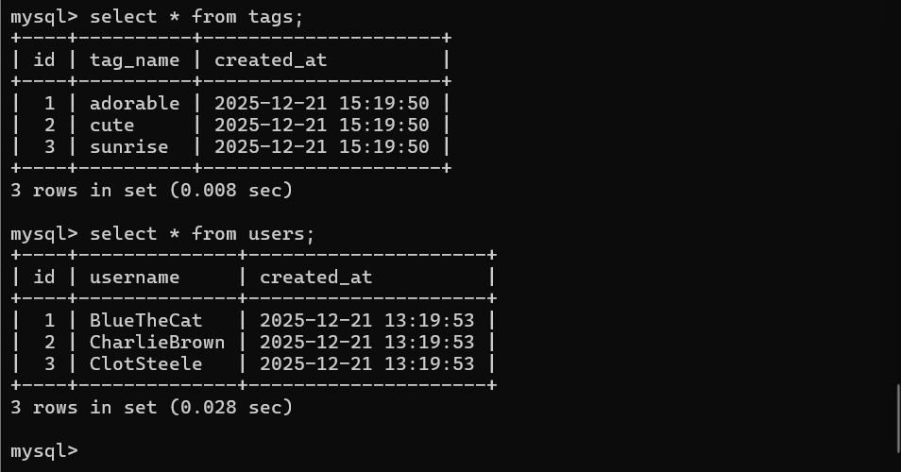

COMPLETE CODE

- CREATE TABLE users (
- id INTEGER AUTO_INCREMENT PRIMARY KEY,
- username VARCHAR(255) UNIQUE NOT NULL,
- created_at TIMESTAMP DEFAULT NOW()
- );

- CREATE TABLE photos (
- id INTEGER AUTO_INCREMENT PRIMARY KEY,
- image_url VARCHAR(255) NOT NULL,
- user_id INTEGER NOT NULL,
- created_at TIMESTAMP DEFAULT NOW(),
- FOREIGN KEY(user_id) REFERENCES users(id)
- );

- CREATE TABLE comments (
- id INTEGER AUTO_INCREMENT PRIMARY KEY,
- comment_text VARCHAR(255) NOT NULL,
- photo_id INTEGER NOT NULL,
- user_id INTEGER NOT NULL,
- created_at TIMESTAMP DEFAULT NOW(),
- FOREIGN KEY(photo_id) REFERENCES photos(id),
- FOREIGN KEY(user_id) REFERENCES users(id)
- );

- CREATE TABLE likes (
- user_id INTEGER NOT NULL,
- photo_id INTEGER NOT NULL,
- created_at TIMESTAMP DEFAULT NOW(),
- FOREIGN KEY(user_id) REFERENCES users(id),
- FOREIGN KEY(photo_id) REFERENCES photos(id),
- PRIMARY KEY(user_id, photo_id)
- );

- CREATE TABLE follows (
- follower_id INTEGER NOT NULL,
- followee_id INTEGER NOT NULL,
- created_at TIMESTAMP DEFAULT NOW(),
- FOREIGN KEY(follower_id) REFERENCES users(id),
- FOREIGN KEY(followee_id) REFERENCES users(id),
- PRIMARY KEY(follower_id, followee_id)
- );

- CREATE TABLE tags (
- id INTEGER AUTO_INCREMENT PRIMARY KEY,
- tag_name VARCHAR(255) UNIQUE,
- created_at TIMESTAMP DEFAULT NOW()
- );

- CREATE TABLE photo_tags (
- photo_id INTEGER NOT NULL,
- tag_id INTEGER NOT NULL,
- FOREIGN KEY(photo_id) REFERENCES photos(id),
- FOREIGN KEY(tag_id) REFERENCES tags(id),
- PRIMARY KEY(photo_id, tag_id)
- );

